Project Report

Of

Me504

Assignment 1

By

Spandan seth

Entry number -2022MEB1348

**Q1)**

* **Objective Function vs Iteration Plots For Different functions**

1. **g = 5*x2 - 30*x + y2 - 8*y + 4*x*y + 34**

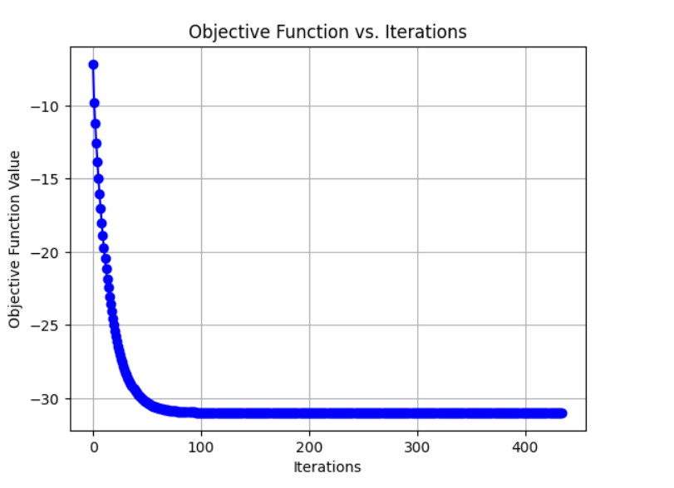

**For Learning Rate λ=0.1**

**Final x is: 6.99999884509287**

**Final y is: -9.99999721180754**

**Value of g at the final point: -30.9999999999984**

**These Values are with a tolerance of 0.000001**.

1. 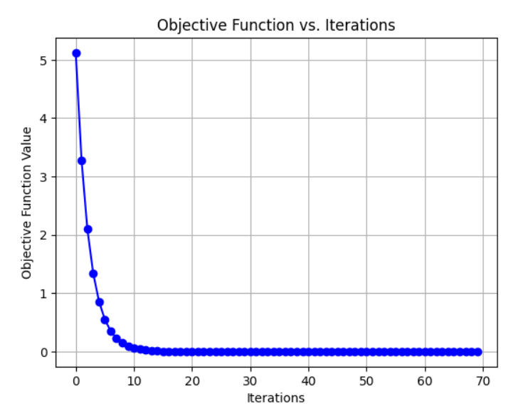**g=x2 + y2 - 4*x - 4*y + 8**

**For Learning Rate λ=0.1**

**Final x is: 1.99999967089909**

**Final y is: 1.99999967089909**

**Value of g at the final point: 2.16715534406831E-13**

**These Values are with a tolerance of 0.000001**.

1. 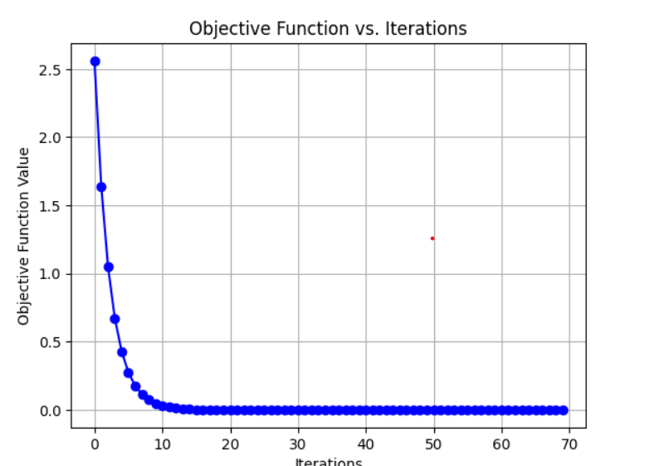**g=(x-2)2**

**For Learning Rate λ=0.1**

**Final x is: 1.99999967089909**

**Final y is: 0**

**Value of g at the final point: 1.08307409891862E-13**

**These Values are with a tolerance of 0.000001**.

* **Now We can use the function**

**g=x2 + y2 - 4*x - 4*y + 8**

**And Change the learning Rate to different Value**

**For**

1. **λ=0.1**

**We have seen the following graph**

**Final x is: 1.99999967089909**

**Final y is: 1.99999967089909**

**Value of g at the final point: 2.16715534406831E-13**

1. 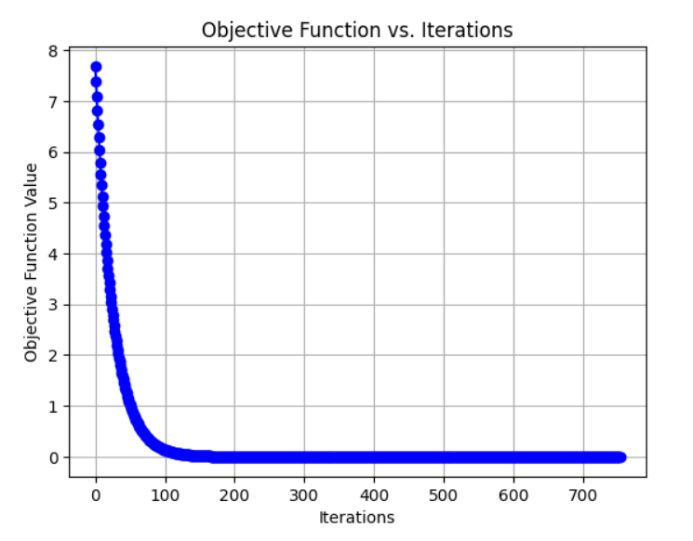**λ=0.01**

**Final x is: 1.99999951527986**

**Final y is: 1.99999951527986**

**Value of g at the final point: 4.69846384021366E-13**

1. 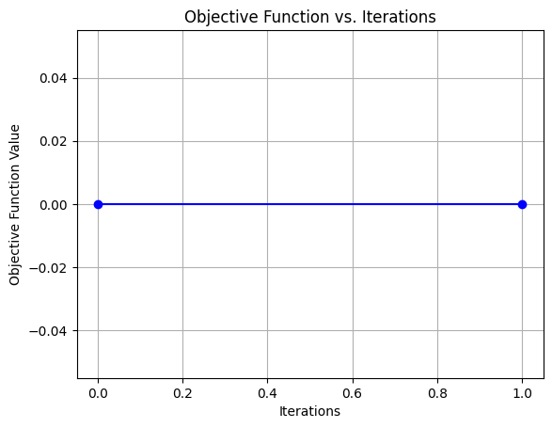**λ=0.5**

**Final x is: 2.00000000000000**

**Final y is: 2.00000000000000**

**Value of g at the final point: 0**

**From this we see that for**

1.Smaller Learning Rate(λ=0.01) we get convergence after many points but its is stable and we observe a smooth, gradual decrease in the objective function over Iterations.

2.Moderate Learning Rate(λ=0.1) we get convergence after a decent amount of time and it is also stable enough, it is a compromise between stability and speed. Also a smooth and gradual decrease in objective function over Iterations.

3.Larger Learning Rate (λ=0.5) we get convergence very fast but it is not stable it might be posible of overshooting or divergence of function.

Therefore as we increase the value of learning rate we compromise our stability with increase in speed and also increase the risk of Divergence.

**Q2)**

**We have the following function**

**F(x, y) = (x2 + ay2) For**

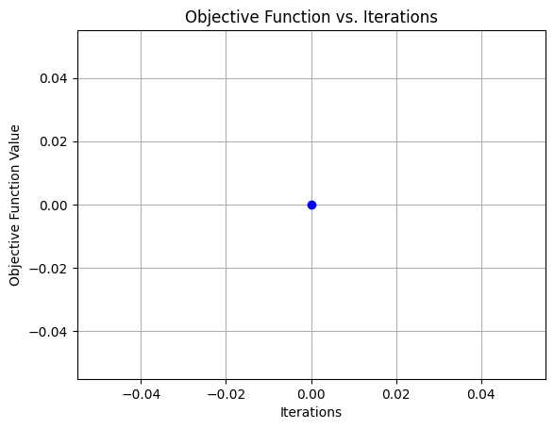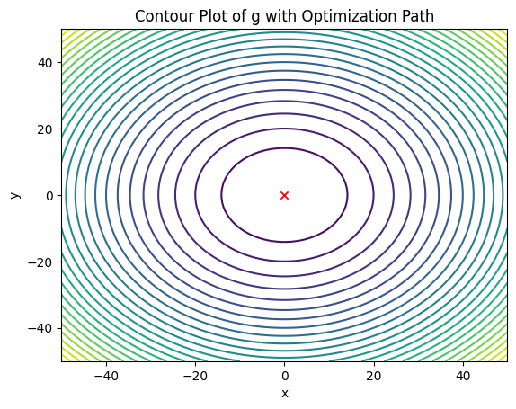**1.a=1**

**Final x is: 0**

**Final y is: 0**

**Value of g at the final point: 0**

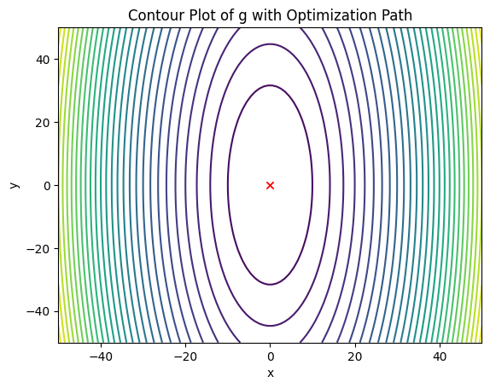**2. For a=0.1**

**Final x is: 0**

**Final y is: 0**

**Value of g at the final point: 0**

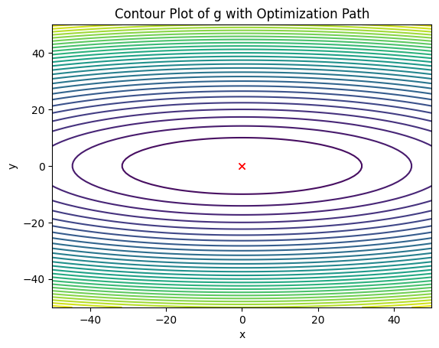**3. For a=10**

**Final x is: 0**

**Final y is: 0**

**Value of g at the final point: 0**

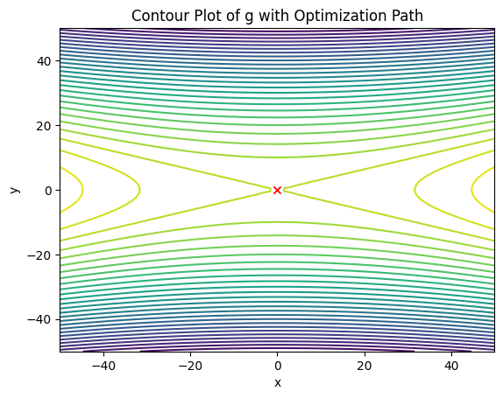**4. For a=-10**

**Final x is: 0**

**Final y is: 0**

**Value of g at the final point: 0**

**From these different values of a we observe that when**

1. **a=1 we get a perfect Circle Levels of Contour Map**
2. **0<a<1 we get a ellipse which has its major axis in Y Direction as ay2 term is smaller.**
3. **a>1 we get a Ellipse which has its Major axis in X direction as ay2 term Dominates.**
4. **a<0 we get a Hyperbola which has its major axis in X Direction when a<-1 and will be in Y direction when -1>a>0.**